**IFT 166 Introduction to Internet Networking**

**Lab 26**

**Spot the difference III**

**After you complete each step, put a ‘√’ or ‘x’ in the completed box   
&**

**Provide answers to the 4 open questions**

**Objective**

By comparing the configurations in two topologies, find configuration errors.

1. In packet tracer, open the file “Spot the difference III” (located in the modules sections below this lab).   
     
   You should see the following 2 topologies.

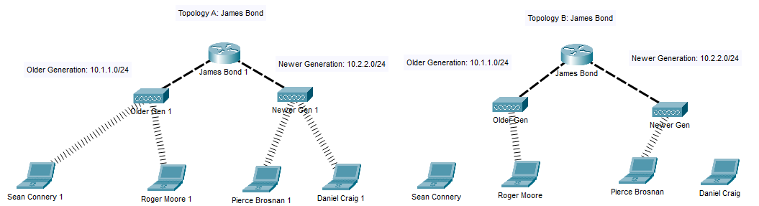



1. All the laptops can ping each other in Topology A.

All the laptops in Topology B should be able to ping each other. This is the not the case.  
  
There are 4 configuration differences in the 2 topologies (the 4 incorrect configurations are on Topology B)

**Spot the 4 differences.**

1. List each difference and why it needs to be corrected to allow the communications.



_____________________________________________________________________

_________________________________________________________________________

_________________________________________________________________________

_________________________________________________________________________

_____________________________________________________________________

_________________________________________________________________________

_____________________________________________________________________

_________________________________________________________________________

**Bonus 20 points**

Why could I not make the 2 topology configurations the same?

_________________________________________________________________________

_________________________________________________________________________